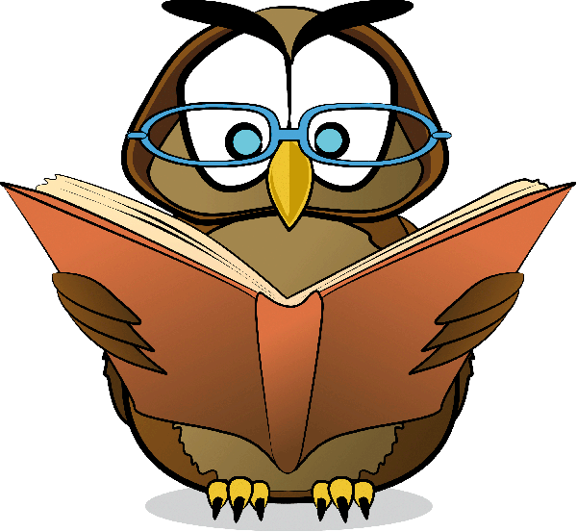ST. JOHN’S BOOK CLUB

Meets the 1st & 3rd Tuesday at 6:30 PM in the Family Room

Here are a few of our previously read books: “The Guernsey Literary and Potato Peel Pie Society” by Maryann Shaffer and Anne Barrows. “Behind Closed Doors” by B.A. Paris. “The Second Mrs. Hockaday” by Susan Rivers. “Eat, Pray, Love: One Woman’s Search for Everything Across Italy, India, and Indonesia” by Elizabeth Gilbert. “Beartown” by Fredrik Backman. “If You Knew Her” by Emily Elgar. “The Christmas Train” by David Baldacci.

